#1 Relief: Immediate actions taken to halt the deterioration of economy.
Civilian Conservation Corps (CCC) - How did the CCC contribute to environmental preservation?
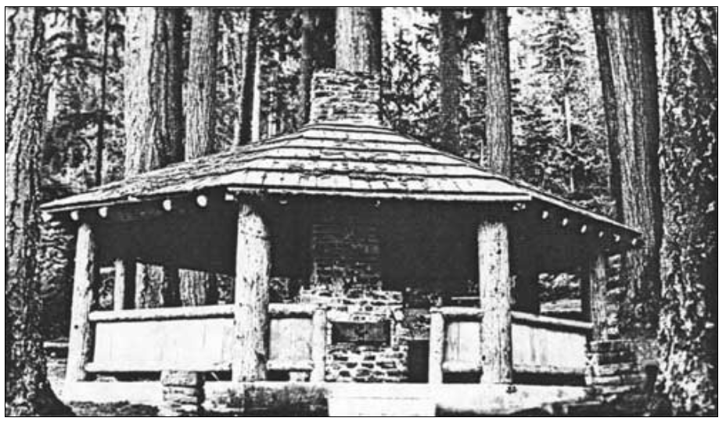
“Perhaps more than any other single New Deal program, the CCC restored a sense of working dignity to its enrollees while simultaneously bestowing care and craftsmanship on the areas in which it worked. Throughout America, CCC workers created campgrounds, roadways and other recreation and Park support facilities…The Elwha and Altaire community kitchens and Soleduck Falls shelter are perhaps the most obvious public facilities, but other campgrounds, ranger stations and trails benefited as well.”
Under the direction of the National Forest Service, CCC enrollees from Snider CCC Camp, built the octagonal community kitchen in the La Poel picnic area, during the winter of 1934-1935. Only the concrete foundation slab remains today. (Courtesy of Olympic National Park)

https://www.nps.gov/parkhistory/online_books/olym/hrs/chap5.htm

#2 Recovery: Pump – Priming = Temporary programs to restart the flow of consumer demand.
How did the WPA and PWA contribute to environmental preservation?
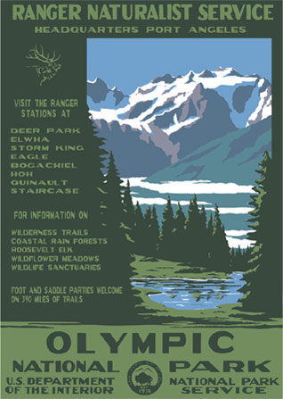
“As part of President Franklin Roosevelt's New Deal administration, two programs, in addition to the Civilian Conservation Corps, that greatly facilitated the solid administrative establishment of Olympic National Park, were the Public Works Administration (PWA) and the Works Progress Administration (WPA)… Roads for the headquarters area on southeast Peabody Heights, Port Angeles, have been cleared and rough grading is in progress. . . . Excavation for the warehouse, the first building to be constructed, is beginning this week. Finish grading of the utility area will be complete by the end of the week. . . . The administration building and superintendent's residence sites are staked for construction and excavation is expected to be completed by October 31. . . . Sewer and water and power and telephone service lines are to be staked and excavated. All materials for sewer, power and telephone connections have been purchased. . . .” https://www.nps.gov/parkhistory/online_books/olym/hrs/chap5.htm

#3 Reform: Permanent programs to regulate against economic depression and disasters.
How did the creation of Olympic National Park regulate against economic disaster?
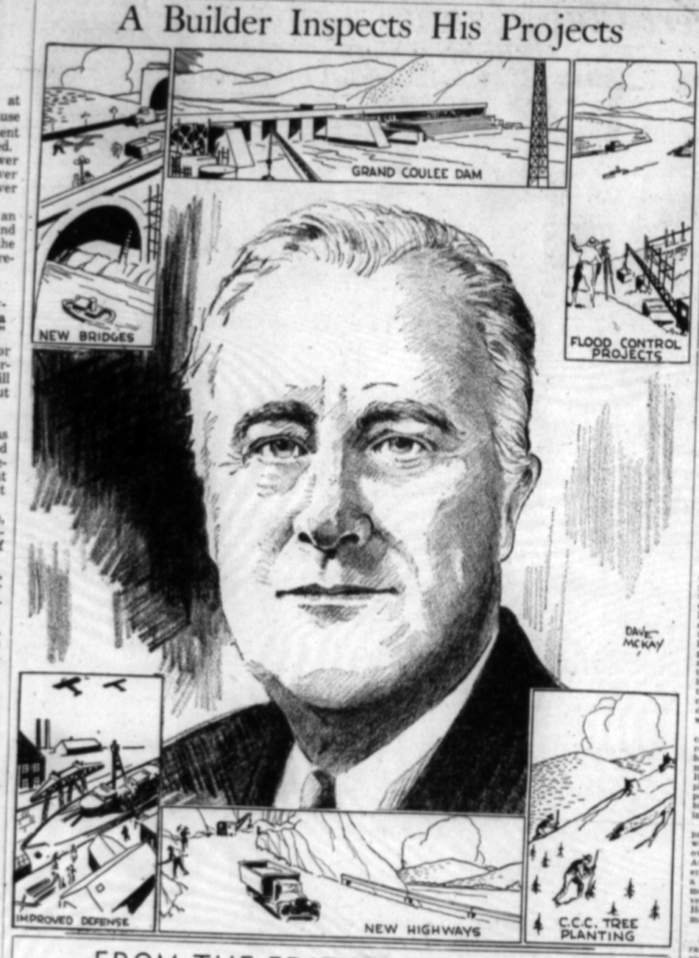
“Mr. Roosevelt pledged that the park would be created not only for ‘us old people,’ but for the children of today and of the next hundred years.” (Seattle Post Intelligence, Oct 1, 1937)
“Where there is no vision, the people perish; but he that keepth the law, happy is he.” Proberbs 29:18 (quote accompanies Cartoon in the Seattle Post Intelligence, Sept 29, 1937)

